Dan Scott Ranch Management Program Application Form

Please **answer the following questions to the best of your ability. For the essay questions, be concise and** limit your answers to no more than a single page for each question, double spaced in a 12- point font.

## General Questions

1. Do you have a dog that you will need to take with you this summer? Yes No
2. Have you been convicted of DUI or another offense that would limit your ability to be insured to drive a host-ranch vehicle? Yes No
3. Most host ranches are very accommodating for family-related leave, weddings, and other commitments of short duration. Do you have any lengthy commitments that would prevent you from serving a full 12 weeks in your internship? Yes No
4. What is the monthly salary, in addition to housing, that you expect to receive when working as a intern? **$________________________**

## ESSAY QUESTIONS – Please include the question text at the top of each answer page

1. ESSAY QUESTION: What do you believe are two essential professional skills that a ranch manager should possess? What are your strengths and weaknesses relative to these skills and how will this degree program grow your strengths and help you address and overcome your weaknesses?
2. ESSAY QUESTION: In your opinion, what are the two most important short-term (e.g. 2 years) and the two most pressing long-term (e.g. 10-20 years) issues / challenges facing the ranching industry in the US?
3. ESSAY QUESTION: Acceptance into the DSRMP includes two summer sessions as an intern on a working ranch. Describe your ideal host ranch. What are your goals for the 12-week internship (what would you like to learn, what experience do you wish to gain, what skills would you like to build or acquire)? What is your plan for achieving these goals during the internship?

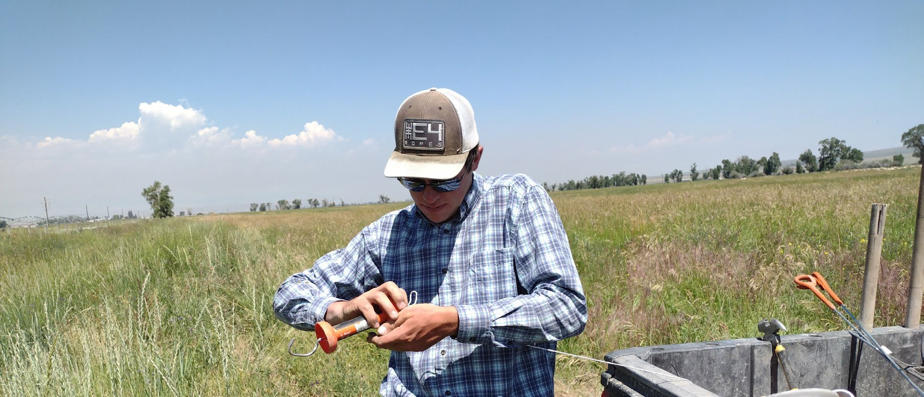

The Dan Scott Ranch Management Program

Skills Assessment

## Skills Assessment – Please check the box that best describes your experience in each of the following skills / activities: “***Competent***” = can perform without supervision / help “***Have Done***” = Done in the past, but would need help or additional training “***New to This***” = No experience with this task or skill

|  |  |  |  |  |  |  |  |  |
| --- | --- | --- | --- | --- | --- | --- | --- | --- |
| **Livestock Husbandry** | Competent | Have Done | New to this |  | **Infrastructure** | Competent | Have Done | New to this |
| Horseback riding |  |  |  |  | Electric fence – set up and troubleshoot |  |  |  |
| Horseshoeing and / or hoof trimming |  |  |  |  | Barbed wire and net wire fencing & repair |  |  |  |
| Pasture roping / doctoring of livestock |  |  |  |  | Flood irrigation – ditch and dam maintenance |  |  |  |
| Pen roping |  |  |  |  | Pivot irrigation |  |  |  |
| Low-stress livestock handling |  |  |  |  | Wheel line irrigation |  |  |  |
| Administering vaccinations |  |  |  |  | Hand line irrigation |  |  |  |
| Basic wound care |  |  |  |  | Basic plumbing |  |  |  |
| Assisting with birth of calves / lambs |  |  |  |  | Basic electrical |  |  |  |
| Newborn animal care |  |  |  |  | Welding |  |  |  |
| Disease recognition and treatment |  |  |  |  | Carpentry |  |  |  |
| Heat detection for AI |  |  |  |  | Power hand tools (skillsaw, drill, impact, etc.) |  |  |  |
| AI breeding |  |  |  |  |  |  |  |  |
| Intensive grazing management |  |  |  |  |  |  |  |  |
|  |  |  |  |  |  |  |  |  |
| **General Skills** | Competent | Have Done | New to this |  | **Equipment operation & maintenance** | Competent | Have Done | New to this |
| Plant identification |  |  |  |  | Tractor |  |  |  |
| Rangeland monitoring |  |  |  |  | Hay equipment (swather, baler, rake) |  |  |  |
| Leather working / repair |  |  |  |  | Skidsteer operation |  |  |  |
| GPS/GIS mapping |  |  |  |  | ATV and UTV operation |  |  |  |
| Marketing and design |  |  |  |  | Trailer driving / backing |  |  |  |
| Second language |  |  |  |  | Trailer wiring |  |  |  |
|  |  |  |  |  | Drive a stick shift transmission |  |  |  |
| Additional skills: list any skills that would be beneficial to ranch |  |  |  |  | Backhoe operation |  |  |  |
|  |  |  |  |  | Drive a dump or semi-truck truck |  |  |  |
|  |  |  |  |  | Change a flat tire |  |  |  |
|  |  |  |  |  | Small engine repair |  |  |  |
|  |  |  |  |  | Equipment maintenance – grease/oil, clean air filter, etc. |  |  |  |